

Deemed-to-be-University
B. S. Devashi Marg (Govandi Station Road) Deonar, Mumbai, Maharashtra 400088
https://www.iipsindia.ac.in/
IIPS-IRB Application Form

Serial No of IIPS-IRB Management Office:
International Institute for Population Sciences

International Institute for Population Sciences -Institutional Review Board (IIPS-IRB) Application form for the review of the proposal
General instructions:
- To be filled by the Principal Investigator (PI);
- Please tick mark the appropriate one, mark NA if not applicable; and
- Attach a separate sheet if required

Title of the Proposal : ……………………………………………………………. Name of the Applicant : ……………………………………………………………. Name of the Principal Investigator : ……………………………………………………………. Designation : …………………………………………………………….
Department : ……………………………………………………………. Date of submission : …………………………………………………………….
Type of review
Exemption from Review …  Expedited Review ... Full Committee Review … 

Status of Review: New… Revised…

SECTION A: ADMINISTRATIVE INFORMATION
Project Investigators | Name, Qualifications and Designation | Department and Organization Address and  contact details | Roles and responsibilities | Signature
PI:
Co-PI:
Please attach a brief bio and CV for all investigators (PIs and Co-PIs) involved in the study (with subject specific publications limited to the previous 5 years).

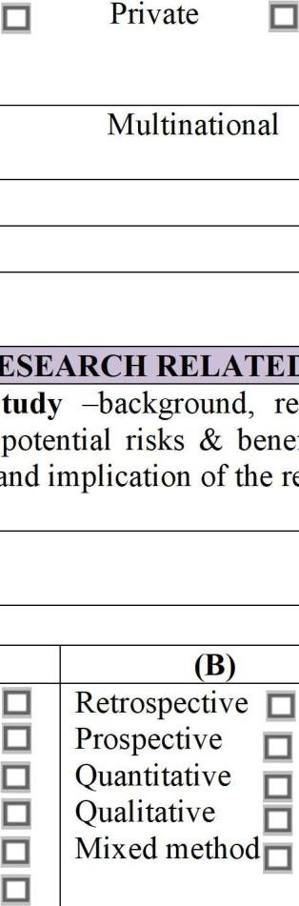
Funding Details

Project Duration:
Total Budget:
Share of the sponsor/s in the total budget:
Sponsor Information:
1. Indian a) Government i. Central ii. State iii. Institutional
b) Private i. Industry ii. Development agency iii. Self-sponsored
2. International Government Private UN agencies Other
3. Industry National Multinational
Specify the funding agency:
Contact Address of Sponsor:

SECTION B: RESEARCH RELATED INFORMATION
1. Brief description of the study –background, research question aim(s) & objectives, methodology describing the potential risks & benefits, monitoring and auditing, outcome measures, statistical analysis and implication of the research findings (maximum 500 words):
2. Objectives of the study
Type of Study: (Tick √ / ☓)
(A) | (B) |   (C)
Socio-Behavioural Science | Retrospective | Cross sectional
Clinical Single center | Prospective | Longitudinal/cohort
Clinical Multi- centric Epidemiological and Public health Basic science  Biological sample | Quantitative Qualitative Mixed method | Case control  Systematic review Baseline  Endline
 |  | Formative

- Clinical Trials:  Drug /Vaccines/Device/Herbal Remedies:  - Does the study involve use of:  Drug Devices  Indian Systems of Medicine/ Any other Alternate System of Medicine |  | Vaccines NA
ii. Is it approved and marketed  In India UK & Europe  Other countries, specify | USA
iii. Does it involve a change in use, dosage, route of administration?  If yes, whether DCGI’s /Any other Regulatory authority’s Permission is obtained?  If yes, Date of permission: |  | Yes | No
 |  | Yes | No
iv. Is it an Investigational New Drug?  If yes, IND No: |  | Yes | No
a). Investigator’s Brochure submitted |  | Yes | No
b). In vitro studies data |  | Yes | No
c). Preclinical Studies done |  | Yes | No
d). Clinical Study is : Phase I Phase II Phase III | Phase IV
4. Are you aware if this study/similar study is being done elsewhere? |  |  |  | Yes | No
If Yes, provide details
SECTION C: PARTICIPANT RELATED INFORMATION
- Subject selection:
  - Number of Subjects: Sampling design and Sample Size
The rationale for the selection of sample size in 100 words. In case of qualitative study describe the number and type of respondents.
ii. Duration of fieldwork :
iii. Will subjects from both sexes be recruited |  |  |  | Yes | No

iv. Please provide the inclusion and exclusion criteria of the selection of respondents
v. Type of subjects Volunteers Patients
vi. Vulnerable subjects |  | 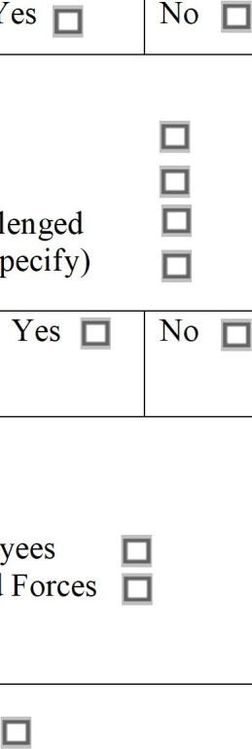  Yes |  | No
If Vulnerable subjects, Tick the appropriate boxes

Pregnant Women Children Elderly

Fetus Illiterate Handicapped Terminally ill Seriously ill Mentally challenged Economically & Socially backward Any other (Specify)
iv. Special group subjects |  | Yes |  | No
If yes in special subject group, tick the appropriate boxes

Captives Institutionalized Employees Students Nurses/Dependent Staff Armed Forces Any Other
- Privacy and confidentiality
  - Study involves - Direct Identifiers Indirect Identifiers/coded
Completely anonymized/ delinked
ii. Confidential handling of data by staff | Yes |  | No |  | NA
- Use of biological/ hazardous materials  - Use of fetal tissue or aborts | Yes |  | No |  | NA
ii. Use of organs or body fluids | Yes |  | No |  | NA
iii. Use of recombinant/gene therapy | Yes |  | No |  | NA
If yes, has Department of Biotechnology (DBT) approval for DNA products been obtained? | Yes |  | No |  | NA
iv. Use of pre-existing/stored/left over samples | Yes |  | No |  | NA
v. Collection for banking/future research | Yes |  | No |  | NA

vi. Use of ionizing radiation/radioisotopes  If yes, has Bhabha Atomic Research Centre (BARC) approval for Radioactive Isotopes been obtained? | Yes | No |  | NA
 | Yes | No |  | NA
vii. Use of Infectious/biohazardous specimens | Yes | No |  | NA
viii. Proper disposal of material | Yes | No |  | NA
ix. Will any sample collected from the patients be sent abroad? | Yes | No |  | NA
If Yes, justify with details of collaborators:
a) Is the proposal being submitted for clearance from Health Ministry’s Screening Committee (HMSC) for International collaboration? |  | Yes | No
b) Sample will be sent abroad because (Tick appropriate box):

Facility not available in India Facility in India inaccessible
Facility available but not being accessed If so, reasons
Informed Consent
Are you seeking waiver of consent? If yes, please specify reasons and skip to item no. 8 Yes No
Type of consent planned
*Written/Signed Oral/Verbal Audio-visual
In case of a minor children:
Verbal assent from of minor (7-12 yrs.) along Written assent from of minor (13-18 with parental consent yrs.) along with parental consent
List of languages in which translation is done

Details of number of consent or/assent to be obtained in the study
i. Tick the included elements in the Consent form
Understandable language Alternatives to participation Statement that study involves research Confidentiality of records Sponsor of study Contact information
Purpose and procedures Statement that consent is voluntary
Risks & Discomforts Right to withdraw
Benefits Consent for future use of biological material Compensation for participation Benefits if any on future commercialization Compensation for study related injury e.g. genetic basis for drug development Translated in local language Need to recontact
*If written consent is not obtained, give reasons:
ii. Who will obtain consent ? PI/Co-PI Nurse/Counsellor
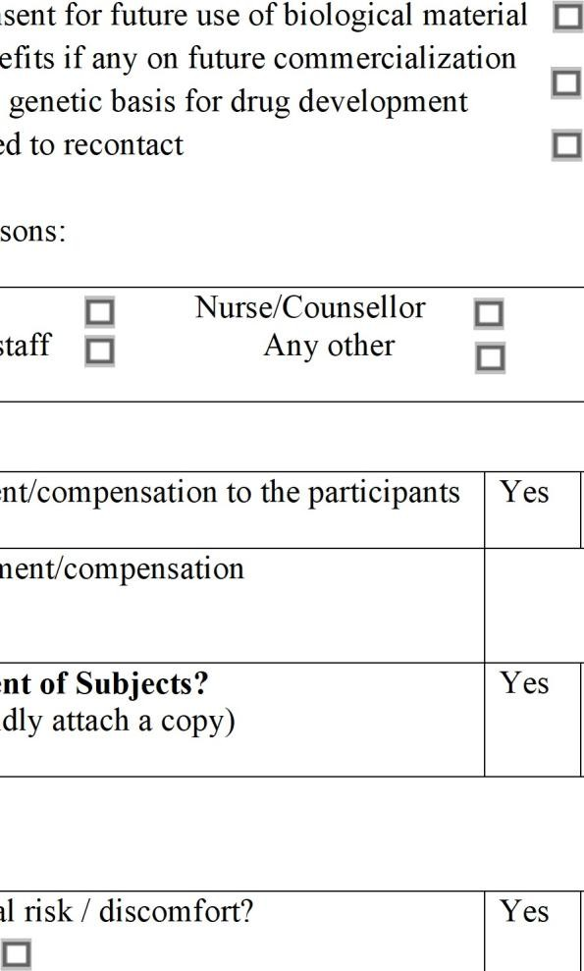
Research staff Any other
8. Payment/Compensation
Will you provide any form of payment/compensation to the participants as a result of their participation? | Yes | No
If yes, please give details of the payment/compensation
9. Will any advertising be done for recruitment of Subjects?  (posters, flyers, brochure, websites – if so kindly attach a copy) | Yes | No
10. Risks & Benefits:
i. Is there physical / social / psychological risk / discomfort?  If Yes, Minimal or no risk More than minimum risk High risk | Yes | No

In case if risks are involved, mention the risks and risk addressing mechanism: Risk
Risk addressal mechanism
ii. Is there a potetial benefit ?

- to the subject No benefit Direct benefit Indirect benefit
- to the society No benefit Direct benefit Indirect benefit
- for improvement in knowledge No benefit Direct benefit Indirect benefit
Mention the benefits:
Storage and Confidentiality
- Identifying Information: Study Involves samples/data. If Yes, Specify Yes No NA
Anonymous/unidentified Anonymized: reversibly coded Irreversibly coded Identifiable
If identifiers must be retained, what additional precautions will be taken to ensure that access is limited / data is safeguarded? (e.g. data stored in a cabinet, password protected computer etc.)
b) Who will be maintaining the data pertaining to the study?
c) Where will the data be analysed and by whom?
d) For how long will the data be stored?
e) Do you propose to use stored samples/data in future studies? Yes No Maybe
If yes, explain how you might use stored material/data in the future?
SECTION D: OTHER ISSUES
- Data Monitoring  - Is there a data & safety monitoring committee/ Board (DSMB)? | Yes | No

iii. Is there a plan for reporting of adverse events?  If Yes, reporting is done to:        Sponsor Ethics Committee DSMB |  | Yes | No
iii. Is there a plan for interim analysis of data? |  | Yes | No
vi. Are there plans for storage and maintenance of all trial database?  If Yes, for how long? |  | Yes | No
12. Is there compensation for participation?  If Yes, Monetary In kind Specify amount and type: |  | Yes | No
13. Is there compensation for injury?  If Yes, by Sponsor by Investigator  by Insurance by any other company |  | Yes | No
14. Do you have conflict of interest? (financial/nonfinancial)  If Yes, specify : |  | Yes | No
SECTION E: CHECK LIST AND DECLARATION
Cover letter | Yes | No | NA
Copy of filled-in and duly signed IRB Form | Yes | No | NA
Project proposal | Yes | No | NA
Short bio of the invigilators | Yes | No | NA
Curriculum Vitae of Investigators in prescribed format | Yes | No | NA
In case of collaborative research, attach the MOU with the collaborating organization | Yes | No | NA
Format of review type  (Exemption from Review/ Expedited Review/ Full Committee Review) | Yes | No | NA
Participant information sheet-cum-Informed Consent form, (if multiple respondents, consent should be taken from each respondent) | Yes | No | NA
Informed Assent form (If applicable) | Yes | No | NA

Investigator self-declaration form | Yes | No | NA
Questionnaire and/or Copy of clinical trial protocol and/or interview guidelines | Yes | No | NA
Investigator’s brochure for recruiting subjects | Yes | No | NA
Copy of advertisements/Information brochures | Yes | No | NA
Institutional Animal Ethics Committee clearance | Yes | No | NA
Any other specify | Yes | No | NA
CPCSEA clearance, if any | Yes | No | NA
HMSC/DCGI/DBT/BARC clearance if obtained | Yes | No | NA
Survey Protocol on COVID-related Measures | Yes | No | NA
Any other information:

Note: Submit 4 copies of each document.
Date: Principal Investigator
Place:



Deemed-to-be-University
B. S. Devashi Marg (Govandi Station Road) Deonar, Mumbai, Maharashtra 400088
https://www.iipsindia.ac.in/

IIPS-IRB

CV Format for Investigators
International Institute for Population Sciences
Format Curriculum Vitae for Investigators

Name:
Present affiliation (Job title, department, and organization):
Address (Full work address):
Telephone number: | Email address:
Qualifications:
Previous and other affiliations (Include previous affiliations in the last 5 years)
Projects undertaken in the last five years:
Relevant research training/ experience in the area:
Attended Ethical Training (if any):
Relevant Publications (Give references to all relevant publications in the last five years):
  Signature | Date: Click here to enter a date.

Deemed-to-be-University
B. S. Devashi Marg (Govandi Station Road) Deonar, Mumbai, Maharashtra 400088
https://www.iipsindia.ac.in/
IIPS-IRB

Expedited Review
International Institute for Population Sciences

Title of study:
Principal Investigator (Name, Designation, and Affiliation):
1. Choose reasons why expedited review from EC is requested¹?
i. Involve non-identifiable specimen and human tissue from sources like blood banks, tissue banks and left-over clinical samples
ii. Involve clinical documentation materials that are non-identifiable (data, documents, records).
iii. Modification or amendment to approved protocol (administrative changes/correction of typographical errors and change in researcher(s))
iv. Revised proposals previously approved through expedited review, full review or continuing review of approved proposals
v. Minor deviations from originally approved research causing no risk or minimal risk
vi. Progress/annual reports where there is no additional risk, for example activity limited to data analysis. Expedited review of SAEs/unexpected AEs will be conducted by SAE
subcommittee.
vii. For multicentre research where a designated EC has approved the proposal, a participating EC may review participating centre specific information and modification in the study
proposal through full committee meeting/ expedited review depending on the importance of local consent related issues involved specific to the centre.
viii. Research during emergencies and disasters (See Section 12 of ICMR Ethical Guidelines,
2017).
ix. Any other (please specify)
2. Is waiver of consent being requested ? Yes |  | No
3. Does the research involve vulnerable person²? Yes |  | No
If Yes give details (attach a separate sheet):
Signature of PI:
Comments of Project Cell:
Signature of Convener:

1Refer to National Ethical Guidelines for Biomedical & Health Research Involving Human Participants 2017, Page 51 Table 4.2 2For details, refer to application for initial review, Section-C, 5(b)
*In case this is first submission, leave it blank

Deemed-to-be-University
B. S. Devashi Marg (Govandi Station Road) Deonar, Mumbai, Maharashtra 400088
https://www.iipsindia.ac.in/
IIPS-IRB
Exemption from Review
International Institute for Population Sciences

Title of study:

Principal Investigator (Name, Designation, and Affiliation):
1. Choose reasons why exemption from ethics review is requested^{1,2}?
i. Research on data in the public domain/ systematic reviews or meta-analyses
ii. Observation of public behaviour/ information recorded without linked identifiers and
disclosure would not harm the interests of the observed person
iii. Quality control and quality assurance audits in the institution
iv. Comparison among instructional techniques, curricula, or classroom management
methods
v. Consumer acceptance studies related to taste and food quality
vi. Public health programmes by government agencies
vii. Any other (please specify in 100 words)
Signature of PI:
Comments of Project Cell:
Signature of Convener:
1Select the category that applies best to your study and justify why you feel it should be exempted from review. For a detailed understanding of the type of studies that are exempt from review, refer to National Ethical Guidelines for Biomedical & Health Research Involving Human Participants 2017, Page 51 Table 4.2
2Such as programme evaluation where the sole purpose of the exercise is refinement and improvement of the programme or monitoring (where there are no individual identifiers)
*In case this is first submission, leave it blank

General Guidelines
[Title of your Institute]

Informed Assent Form (Respondents under age 18)
[Informed assent form should be on the Institute’s letterhead]
Assent refers to agreeing or approving after thoughtful consideration an idea or suggestion to participate in research by a young person below the age of 18 years, who is old enough to understand the implications of any proposed research but not legally eligible to give consent. The assent has to be corroborated with the informed consent of the parent.
Obtaining Informed Assent from Children or Minors Parents, legal guardians, or a legally authorized official must sign consent forms permitting children or minors to participate in research projects. In addition, children and minors are required to sign an Assent Form.
The content of an assent form for children participating in research should be tailored to their age and understanding. It should be written in simple, clear language that aligns with their cognitive, social, and emotional development. Here's a breakdown of key points to include:

Key components to include are:
- Explanation of the Study (Benefit & Purpose):
  - Briefly explain the research project and how it might benefit children like them in a child-friendly way. Mention the activities involved in the study, including any potential discomfort the child might experience.

Study Procedures and Potential Discomfort:
  - Describe the activities involved in the study, using simple language and avoiding medical jargon.
  - Mention any potential discomfort the child might experience and assure them it will be minimized.

Right to Ask Questions and Contact Information:
  - Emphasize that the child can ask questions about the research at any time.
  - Provide contact information for a person the child can reach with questions or concerns (e.g., researcher, parent liaison).

Voluntary Participation and Confidentiality:
  - Clearly state that the child's participation is voluntary and they can refuse to participate or withdraw at any point without impacting their treatment or care.
  - Assure them that refusing will not affect their treatment or care at the center.

Consent and Contact Information:
  - Provide contact information for a person the child can reach with questions or concerns.

Sample:
[Project Title:]
My name is [Your Name], and I'm here to talk to you about a study we're doing about [Project Title and Brief description of the study in child-friendly language].
Your parent(s)/guardian(s) have already given their permission for you to participate, but it's completely up to you if you want to be part of it [explain the voluntary nature of participation and right not to participate and withdraw]
You may feel some inconvenience because of the time and effort to be a participant. You may also find some questions that we ask to be upsetting or may feel embarrassed to answer them [mention any potential discomfort in a gentle way].
You do not have to respond to any question that makes you uncomfortable and you may stop the interview at any time and nothing will happen. There are no direct benefits to participating in the study, although you will help us understand what children like you want or need.
Your participation is entirely voluntary and you can stop the interview at any point of time even after having agreed to participate. If you decide not to participate it will not affect any benefits to which you are entitled. I want to assure you that the information you provide during the study will be kept private and confidential.
If you have any question, please feel free to ask them to me. Or you can also contact the Project PI on the following address. [Address questions of the child regarding the survey if any]
Principal Investigator: [Name, Affiliation, Office, Mobile, Email Address]
[Principal Investigator and Contact Information]
Do you agree to participate in this survey? [Verification of child’s consent] Tick the answer:
- Consent given along with signature/ thumb impression
- Consent given but without signature/thumb impression
- Consent Refused
[Interviewer’s Declaration]
I confirm that the individual has given consent freely. I have taken consent from parents (assent from in case of minor) before the interview

Interviewer’s Name and signature: Date: / /

Guidelines for the Informed Consent An informed consent form must include the following:
- Obtaining an Informed Consent is not simply obtaining a signature on a prescribed format rather, it is a process of sharing information and addressing questions and concerns of the participant.
- It is based on the principle that competent individuals are entitled to choose freely whether or not to participate or continue to participate in the research.
- Participants must then give their consent to participate on an informed consent form developed specifically for the research project.
- There are very few research situations where a participant’s signature on informed consent is not required. However, permission from IRB is always required for waving off of the signature.
- The informed consent form should be submitted in English as well as in local language(s).
- The goal and objective of research in simple jargon-free language. The language should not only be scientifically accurate and simple, but should also be sensitive to the social and cultural context of the participant.
- Informed consent is a continuous process involving three main components:
  - providing relevant information to potential participants,
  - ensuring the competence of the individual, ensuring the information is easily comprehended by the participants, and
  - ensuring voluntariness

IIPS-IRB: Informed Consent Form Part - A

Deemed-to-be-University
B. S. Devashi Marg (Govandi Station Road) Deonar, Mumbai, Maharashtra 400088
https://www.iipsindia.ac.in/
IIPS-IRB

Informed Consent Form
International Institute for Population Sciences

[Project Title:]

[Introduction]
Greetings Self-introduction
Statement mentioning that it is research

[Purpose of Your Study]
  - Clear the research objectives and outcome of the study
  - [Respondent's Role]-Explain the procedure to participate in the interview/survey. Explanation of all the research tools employed. Reasons or methods for inclusion/exclusion of the particular group or individual(s) in the community or in any other settings, for participation in the survey should be briefed.
  - Detailed description of the methodology
  - [Time]-Approx. estimated time to complete the survey
    - The interview will take approximately minutes to complete.

[Risks or Benefits]-
  - Risks: [Describe any potential risks/ discomfort/ inconvenience associated with participation.]
    - You may feel some inconvenience because of the time and effort to be a participant. In case of sensitive surveys, including questions on You may also find some questions that we ask to be upsetting or may feel embarrassed to answer them. You do not have to respond to any question that makes you uncomfortable and you may stop the interview at any time and nothing will happen.

Benefits: [Explain any potential benefits to participants or community.]
    - There are no direct benefits to participating in the study, although you will help us understand what children like you want or need

[Privacy/Confidentiality/Data Security]
  - It is necessary to maintain the privacy and confidentiality of participants at all stages.
  - The extent of privacy, anonymity, and confidentiality that will be provided to participants

    - The information shared by you will be kept confidential and will not be shared with anyone, and will be used only for research purposes.

[Data Sharing- Data collected will be completely anonymized / partially anonymized]
  - The data will only be used for research and planning purposes without any personal identification.

Suppose in the case of Indirect Identifiers, you may give:
  - All the information you provide will be strictly confidential, and your name will not appear on the questionnaire. Instead, your questionnaire will contain an identification number that is known only by the principal investigator of this study.
  - No one including your family members, friends, or other members of the community will ever know that you have not participated in the survey and no one will know what answers you gave since we do not collect information about your name etc.

[Information on any follow-ups of survey if any]
    - The survey team may also re-contact you if it is necessary to complete the information in the survey.

[Voluntary nature of participation and Right not to participate and withdraw]
    - Your participation is voluntary. You may refi1se to participate or may discontinue your participation at any time during the survey. You can also choose not to answer any questions.

[Importance of the response/survey and future use of the information]
    - Your responses are very important to us and the community, as these answers will represent many other people. This is an important study and I hope you will participate fully.

[Contact information]
We will leave the necessary contact information with you. If you have any questions or concerns about this study, please contact on the address given below.

[Address questions of the Respondent regarding the survey if any]
  - Do you have any questions?
    - Should you have any question about the survey please feel free to ask me or contact the concerned authority.

[Principal Investigator and Contact Information]
Principal Investigator: [Name, Affiliation, Office, Mobile, Email Address}

[Consent] Respondent's willingness to participate in the study
  - Do you agree to participate in this survey?

[Verification of consent]

Tick the answer:
- Consent is given along with signature/ thumb impression
- Consent is given but without signature/thumb impression
- Consent Refused

[Interviewer’s Declaration]
I have informed the respondent about the project, risk and benefit and also confidentially risk taken consent from the respondent before the interview.
Interviewer’s Name and signature: Date: / /

IIPS-IRB: Informed Consent Form Part - B

Deemed-to-be-University
B. S. Devashi Marg (Govandi Station Road) Deonar, Mumbai, Maharashtra 400088
https://www.iipsindia.ac.in/
IIPS-IRB

Informed Consent Form
International Institute for Population Sciences

Informed Consent Form
I, , have read the Participant Information Sheet for the above-mentioned project. The information provided in the sheet regarding the nature, purpose, safety, potential risks/benefits, and the expected duration of the study, as well as other relevant details, including my role as a study participant, has been explained to me in a language that I understand.

I confirm that:
  - I have had the opportunity to ask questions, and all my queries have been answered to my satisfaction.
  - I understand that my participation in this research study is entirely voluntary, and I have the right to withdraw from the study at any point without giving any reason and without affecting my current or future medical treatment or relationship with the researchers.
  - I understand the risk & benefits of participating in this study.
  - I understand that refusing to participate or withdrawing will not result in any penalty or loss of benefits to which I am entitled.
  - I understand that my personal information and data collected during this study will be kept confidential. Only the researchers involved in the study, the sponsoring agencies, regulatory authorities, and IRB may access my records if necessary, for monitoring and auditing the study in line with the ethical guidelines.
  - I understand that the data will be anonymized for any future use, and my identity will not be revealed in any reports or publications that come out of this research.

By signing this consent form, I willingly agree to participate in this study. I understand that I can withdraw at any time without giving a reason and without any loss of benefit.
………………………………………………………………………………………………………

For participants with limited or non-readers:
I, [Witness Name], have witnessed the consent procedure of the study participant. The participant had the opportunity to ask questions, and I confirm that the individual has given consent freely and voluntarily after understanding the study's purpose and their role in it.
……………………………………………………………………………………………………… Name of the Participant/Guardian: Signature/Thumb Impression of the Participant/Guardian: Witness (for non-readers): (Signature and Name)

……………………………………………………………………………………………………… Name of the Person Administering the Consent: Signature of the Person Administering the Consent: Date:
……………………………………………………………………………………………………… Principal Investigator (Pl): Contact Information: [Insert PI's Contact Details]

Co-Principal Investigator (Co-Pl): Contact Information: [Insert Co-PI's Contact Details]
………………………………………………………………………………………………………
Note: All parties signing the consent form must date their own signature

IIPS-IRB: Self Declaration Form Part-A

Deemed-to-be-University
B. S. Devashi Marg (Govandi Station Road) Deonar, Mumbai, Maharashtra 400088
https://www.iipsindia.ac.in/
IIPS-IRB

Self-Declaration Form
International Institute for Population Sciences

DECLARATION BY THE PRINCIPAL INVESTIGATOR

Study Title: I hereby declare that:
- Voluntary written consent of the human subject will be obtained.
- In case of children and mentally handicapped subjects-voluntary written informed consent of the parents/guardians will be obtained.
- The probable risk involved in the project will be explained in full details to the subjects/ parents/ guardians.
- Subjects/ parents/ guardians will be at liberty to opt out of the project at any time.
- I will terminate the study at any stage, if have probable cause to believe, in the exercise of the good faith, skill and careful judgement required for me that continuation of the experiment is likely to result in injury, disability of death to the experimental subject.

Date:

(Signature of Principal Investigator) Department

IIPS-IRB: Self Declaration Form Part-B

Deemed-to-be-University
B. S. Devashi Marg (Govandi Station Road) Deonar, Mumbai, Maharashtra 400088
https://www.iipsindia.ac.in/
IIPS-IRB

Self-Declaration Form
International Institute for Population Sciences
(DECLARATION BY THE PRINCIPAL INVESTIGATOR / DIRECTOR)
Study Title:

1) Is the Department/ University ready to undertake the responsibility of the human subjects in case of injury? If yes, then will it include
Yes No NA

- Transportation charges | Yes | No | NA
- Hospitalization | Yes | No | NA
2) Do you think that the study is so designed that they would yield | Yes | No | NA
meaningful results that could not be obtained by the other method?  3) Do you think that the animal experiments carried put support the need | Yes | No | NA

for clinical experimentation?
- Do you think that the study would be conducted in a manner to avoid all unnecessary physical and mental suffering and injury?
- Do you think the experiments have been planned in a manner so that the degree of risk to be taken would never exceed that determined by the humanitarian importance of the problem to be solved by the experiment?
- Do you think that proper preparations would be made and adequate facilities provided to protect the study subject against even remote possibilities of injury, disability or death?
- Do you think that safeguards have been taken to see that the research would be conducted only by scientifically qualified persons who possess the requisite competence, experience and qualities to carry out the research?

Yes No NA Yes No NA

Yes No NA

Yes No NA

Date:

(Signature of Principal Investigator)

(Signature of Director)

Chairperson Dr. Shireen J. Jejeebhoy, Independent Researcher
Convener Prof. Aparajita
Chattopadhyay,
IIPS

Members Prof. Gajanan Velhal, B K L
Walawalkar Rural Medical College, Ratnagiri

Prof. Archana K. Roy, IIPS

Dr. Lalita Savardekar, ICMR-NIRRH

Prof. M. Sivakami,
TISS

Ms. Sushmita Das,
Society for Nutrition,
Education
& Health Action (SNEHA)

Adv. Ashwin C. Thool, Hon'ble High Court of Bombay and Supreme Court of India

Ms. Vijaya S. Durdhawale, IDF

IIPS Letter Head

Institutional Review Board (IRB00013212)
Project title: …………………………………………………………………………………………………
Name & Address of Institution: International Institute for Population Sciences, Deonar, Mumbai - 400088
Principal Investigator:  Name: ……………………………………… Contact Number: ……………………… Email ID: …………………………………. | Name of Co-PIs:  ………………………………………………………………..
Collaborators’ Name: ……………………. Address: ……………………………………….  Contact. No.: ………………………………… Email: ………………………………………….. | Sponsor: ………………………………………………………...
Review Status:
The following item [√] have been received and reviewed in connection with the above study to be conducted by the above investigator.
[…..] Participant Information Sheet […..] Study Protocol / Synopsis
[…..] Summary of Change Document (in case of a revision) […..] Informed Consent Form
[…..] Investigators’ CVs
And have been [√] […..] Approved
Comments (if any):
Date of Approval:
Please note:
- Inform IRB immediately in case of any adverse events and serious adverse events.
- Inform IRB in case of any change of study procedure, site and investigator.
- Members of IRB have right to monitor the pretesting procedure with prior intimation.
- Members of IRB have right to monitor the field procedure with prior intimation.
Convener  IRB Committee |  | Chairperson IRB Committee

No. / …………………….. Date: …………………….

Deemed-to-be-University
B. S. Devashi Marg (Govandi Station Road) Deonar, Mumbai, Maharashtra 400088
https://www.iipsindia.ac.in/
IIPS-IRB

Audit and Inspection Checklist
International Institute for Population Sciences
Audit and Inspection Checklist
1) Date of letter of communication regarding audit/ inspection
2) Date(s) agreed upon for the audit/inspection
3) Ensure IRE-IS members and staff have been informed about the date(s) and time
4) Ensure availability of IRB-1S related information (mandate, terms of reference,
organization chart) in print form in the IRE office
5) Availability of latest signed SOPs in print and/or electronic form in the IRB office
6) Review SOPs and note any omissions or deviations with reasons
7) Availability of all national and international ethics guidelines and regulations in print
and/or electronic form
8) Review ongoing and completed research study files for signed documents, noting any
missing/incomplete documents and actions taken
9) Ensure availability of documents regarding list of members, tenure, appointment details,
CYs, and training of IRB members
10) Ensure documents regarding staff appointments, CVs, and training of IRE members are
available
11) Ensure security measures for the electronic database and office records are in place
12) Confirm proper maintenance, retrieval, storage, archival, and tracking of study files per
SOPs
13) Confirm proper labelling and indexing of study files and storage cabinets
14) Designate members to communicate with auditors/inspectors, be available for audit,
prepare action plan, and conduct follow-up audit (if applicable)
15) Report audit findings and inspection report at the full board IRE-IS meeting
16) Arrange for meeting venue, catering, accommodation, and travel for the visit if necessary

