Workshop and Interactive Session on Research Ethics
IIPS-IRB | 28 July 2026 | International Institute for Population Sciences, Mumbai
The Institutional Review Board (IIPS-IRB), IIPS, organised a Workshop and Interactive Session on Research Ethics on 28 July 2026. The programme brought together Institutional Review Board members, faculty members, and PhD scholars to engage in meaningful discussions on ethical issues encountered in research and the role of ethics review in ensuring responsible research practices. IIPS IRB has received DHR certification and is therefore required to adhere to the prescribed guidelines and ethical standards. During the session, the six IRB members, faculty members, and PhD scholars raised several insightful and thought-provoking issues. These discussions highlighted many of the ethical and procedural challenges currently faced in research and underscored the need for continued dialogue to strengthen research ethics.
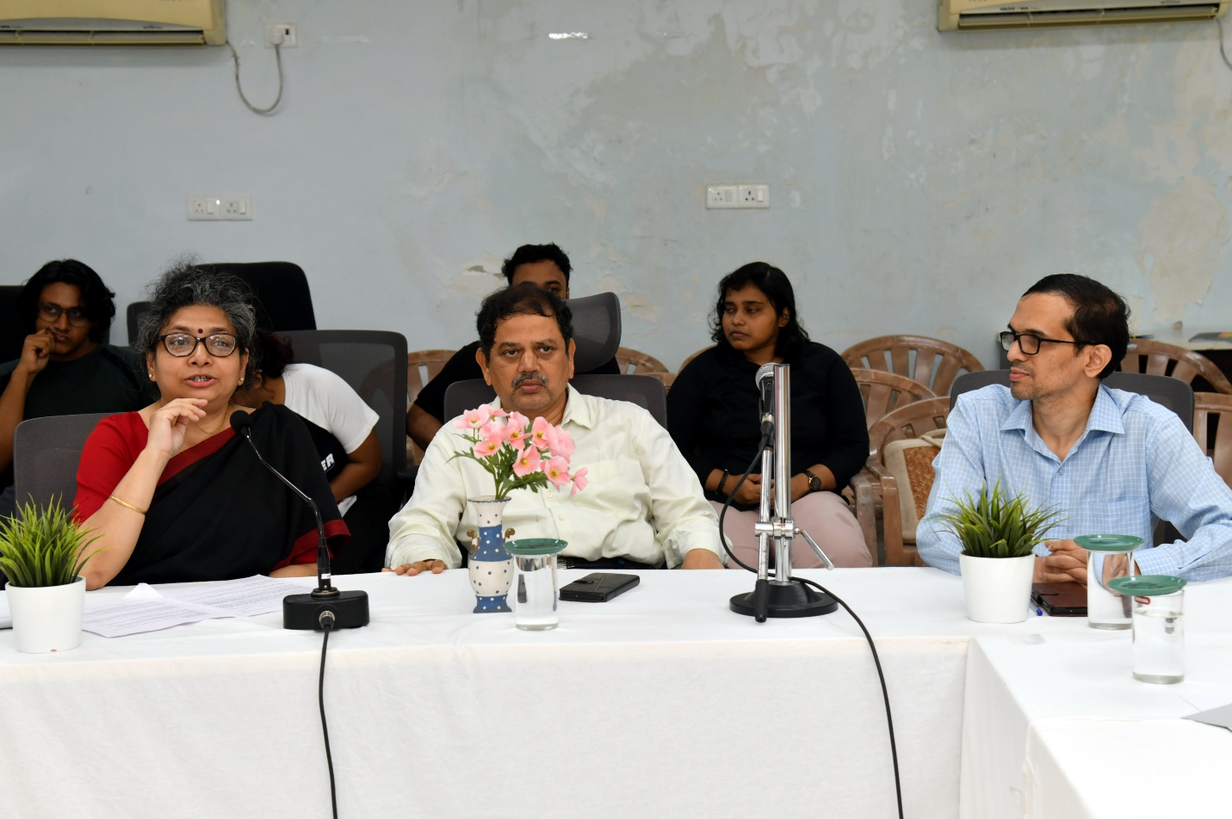
Introduction and welcome address to the speakers at the Workshop.

The workshop featured two distinguished experts in research ethics who shared their knowledge and practical experiences.
Talk 1: Ethical Considerations in Mental Health and Social Science Research
Speaker: Dr. Nilesh Gawde
Dr. Gawde highlighted the unique ethical challenges associated with mental health research in demography and the social sciences, distinguishing them from clinical trials involving psychoactive drugs. He discussed important issues related to participant eligibility, informed consent, autonomy, and benefit-risk assessment. The session also emphasized that social science research, although often perceived as low risk, can expose participants to psychological and social harms. The speaker underscored the need for researchers to anticipate such risks and adopt appropriate safeguards to protect participants and effectively manage adverse events.
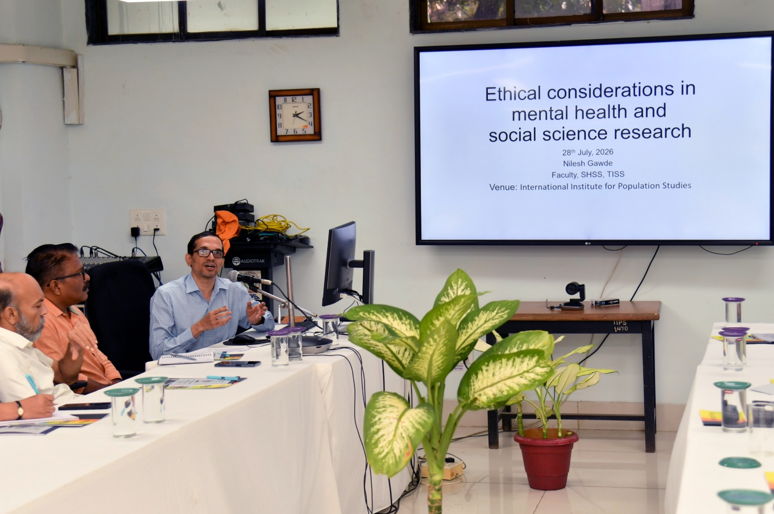
Dr. Nilesh Gawde delivering talk on ethical considerations in mental health and social science research.

Talk 2: Ethical Considerations in Varying Research Projects: A Macro-to-Micro Perspective
Speaker: Dr. Lalita Sarvedekar
Dr. Sarvedekar presented a comprehensive overview of research ethics, examining ethical considerations from both macro- and micro-level perspectives. Her presentation covered the broader regulatory and institutional framework governing ethical review, followed by practical guidance on addressing study-specific ethical issues. The session illustrated how ethical principles are applied throughout the research process, from protocol review and project approval to post-approval monitoring, audits, and continued compliance with ethical guidelines.
Participants gained a deeper understanding of the scope of ethical review, the responsibilities of Institutional Review Boards in project clearance, and the importance of ongoing monitoring and auditing to ensure adherence to ethical standards. The workshop served as an important platform for strengthening awareness of research ethics and promoting ethical conduct in research across disciplines.
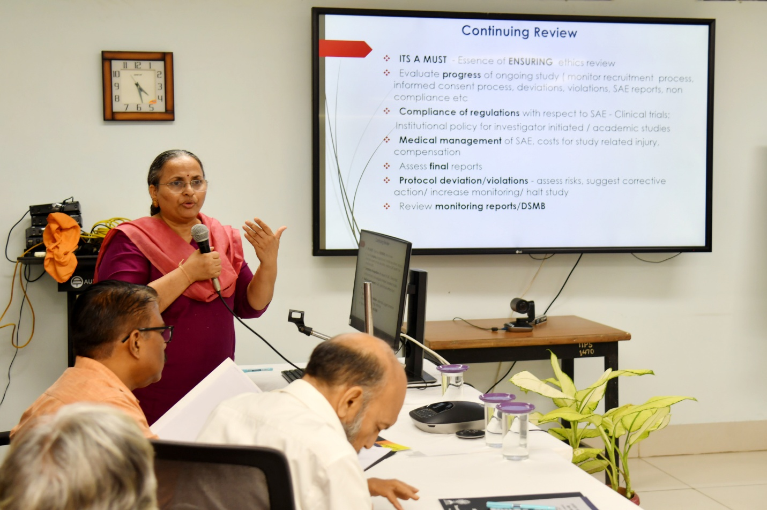
Dr. Lalita Sarvedekar presenting on ethical considerations across research projects.

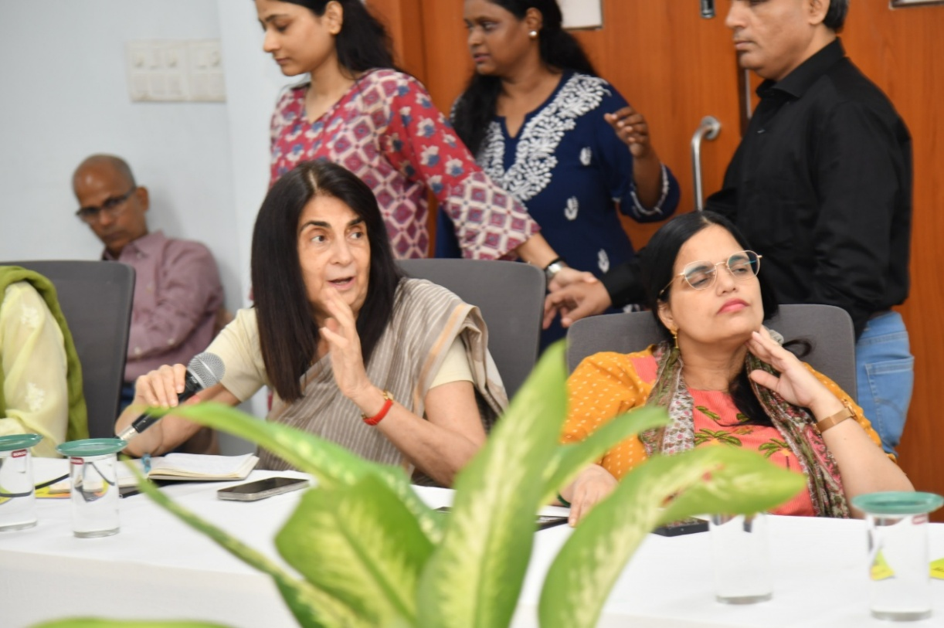
Participants engaging during the open discussion segment of the workshop.

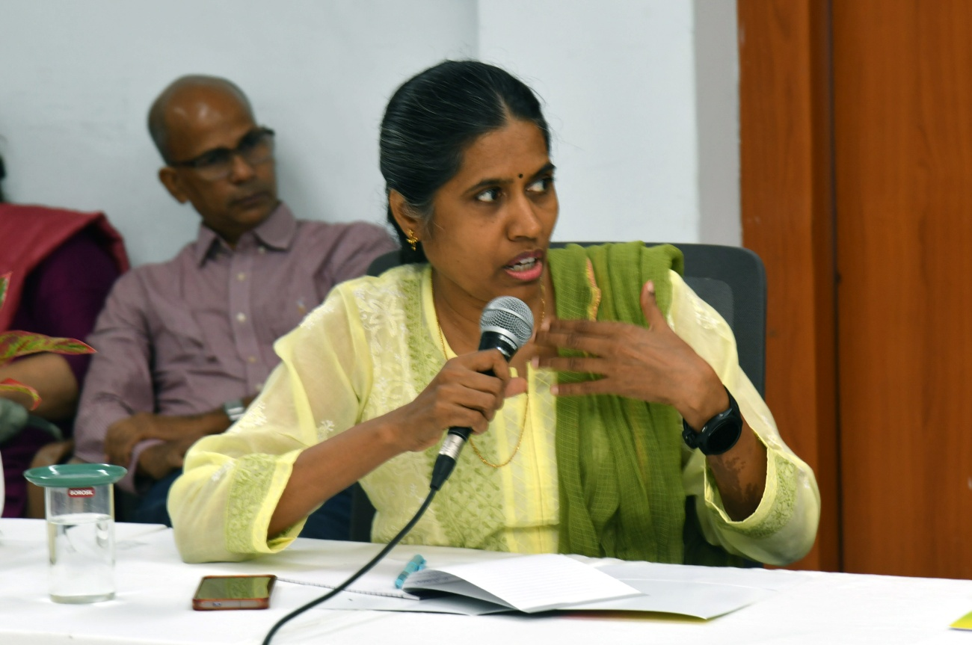
Participants engaging during the open discussion segment of the workshop.

