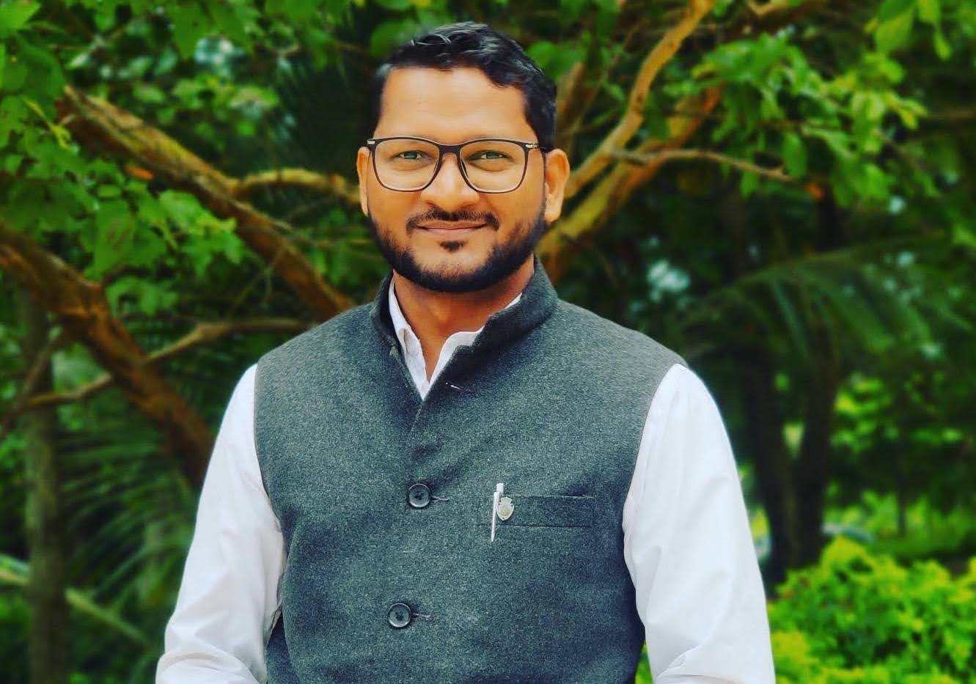

​**Pradeep Salve, Ph.D.**

**Assistant Professor**

Department of Population and Development

International Institute for Population Sciences (IIPS)

(Deemed University)  
An Autonomous Institute Under the Ministry of Health and Family Welfare  
(Government of India)

Govandi Station Road, Deonar, Mumbai -  400 088.

Email: [pradeep_salve@iipsindia.ac.in](mailto:pradeep_salve@iipsindia.ac.in) | [pradeep8889@gmail.com](mailto:pradeep8889@gmail.com)

Office Tel.: 022 - 42372410

Office Website: <https://www.iipsindia.ac.in/deparment-faculties/4385>

**RESEARCH AREAS:** Demography, Population and Development, Public and community health, Maternal, neonatal and child health, Occupational health hazards, Gender issues and health, social stratification and inequalities, Caste and gender, Health policy and programmes.

**PROFILE**

**Dr. Pradeep S. Salve is an Assistant Professor in the Department of Population and Development at the International Institute for Population Sciences (IIPS), Mumbai.** His research interest areas are Population studies, Public and community Health, Violence against women, Maternal and child health, Occupational health hazards, Caste and gender. He has been teaching the Gender health and development, Healthcare system and policies and Occupation health, Historical demography. He has been working with sanitation workers to understand the intersectionality of Caste, Gender and Occupation for last six years. He has five years of teaching and 10 years of research experience in the field population studies. He is a BIARI-Fellow-2015 at Brown International Advanced Research Institutes in Brown University, USA. He has been engaged in monitoring and evaluation of the National Health Missions, National Health Flagship Programmes and Public Health Facilities in India. He is also one of the Principal Investigator of the “Global Adult Tobacco Survey – 3” and “Mapping the risk factors and consequences of violence against women in India.” funded by the MoHFW and BMGF respectively. He is working with various large-scale survey data including National Family Health Survey (NFHS), GATS, Longitudinal Ageing Study of India (LASI), and Health Management Information System (HMIS). He is also member of the different Socially Backward Caste Commissions of Maharashtra State. He has published several research articles in peer-reviewed international journals.

**EDUCATIONAL QUALIFICATION**

* **Doctor of Philosophy (PhD)** in Population Studiesat the International Institute for Population Sciences (IIPS), Mumbai, May, 2018.
* **UCG-JRF and NET in Population Studies 2012**
* **Master of Philosophy** **(M.Phil.) in** Population Studiesat the International Institute for Population Sciences (IIPS), Mumbai, May, 2013
* **Master of Arts (MA)**. Population Studiesat the International Institute for Population Sciences (IIPS). Mumbai, 2012

**ACADEMIC POSITIONS**

* Assistant Professor in the Department of Population and Development at the International Institute for Population Sciences (IIPS), Mumbai from September 2021
* Assistant Professor in the Population Research Centre (PRC), Dharwad, Karnataka from May 2019 to September 2021.

**TEACHING SUBJECTS**

* Historical Demography
* Gender Health and Development
* Healthcare System and Policies
* Occupational Health

**RESEARCH PROJECT AS A PRINCIPAL AND CO-PRINCIPAL INVESTIGATOR**

* Global Adult Tobacco Survey – 3” funded by Ministry of Health and Family Welfare, Government of India (Ongoing)
* Mapping the risk factors and consequences of violence against women in India for the last two decades using large-scale data funded by the Bill Melinda Gates Foundation through Centre of Demography of Gender (Ongoing)

**AWARDS AND FELLOWSHIP**

1. 2021: Received Best **Research Paper Award** *(Second)* by **Ministry of Health and Family Welfare (MoHFW), Government of India** at the 5th Knowledge Dissemination Workshop at Population Research Centre, University of Lucknow, Lucknow.
2. 2015: Received **Fellowship Grant** to attend the workshop on Population and Development: New Approaches to Enduring Problems, Brown International Advanced Research Institutes **(BIARI)**, at **Brown University in Providence, Rhode Island, USA**.
3. 2013: Received the Best **Research Paper Award** at Indian Association for the Study of Population (IASP), 17th December, Haryana, India.
4. 2012:Awarded with the **Junior Research Fellowship** in Population Studies, University Grants Commission, New Delhi, India.

**PUBLISHED RESEARCH PAPERS**

|  |  |  |
| --- | --- | --- |
| 1 | 2023 | Pradeep S. Salve and Chander Shekhar, “Disappearing male sterilization in India: do we care? Contracept Reprod Med. 2023 May 4;8(1):31. doi: 10.1186/s40834-023-00228-w. |
| 2 | 2023 | U S Mishra, Pradeep S Salve, “Indian Masculinity Exposed: Expressed Views on ContraceptiveResponsibility”,Economic & Political Weekly, 2023 vol LVIII no 10 |
| 3 | 2022 | Chhavi Tiwari, Srinivas Goli, Mohammad Zahid Siddiqui and Pradeep Salve, “Poverty, Wealth Inequalities, and Financial Inclusion in Uttar Pradesh: A Comparative Analysis of Castes in Hindu versus Muslim Communities. Journal of International Development, WILEY. <https://doi.org/10.1002/jid.3626> |
| 4 | 2022 | Goli S, Puri P, **Salve, Pradeep,** Pallikadavath S, and K S James "District-Level Estimates of Maternal Mortality Ratio in India and Its Correlates", **PLOS Global Public Health.** |
| 5 | 2022 | Dhananjay Bansod, **Pradeep Salve**, Suresh Jungari *“Caste disparities in health and health care utilization in India”* Caste, COVID-19, and Inequalities of Care, People, Cultures and Societies: Exploring and Documenting Diversities, **Springer Nature Singapore** <https://doi.org/10.1007/978-981-16-6917-0_15> |
| 6 | 2021 | **Pradeep Salve,** Suvarna Naikar, and Jyoti Hallad, **“***Neonatal Deaths in India: A District Level Analysis using Health Management Information System data.* **Demography India.** |
| 7 | 2021 | Pradeep Salve, Shrikanta Vatavati and Jyoti Hallad “The Assessment of Implementation of National STEMI Programme in Goa.” Indian Heart Journal – Elsevier. <https://doi.org/10.1016/j.ihj.2021.05.001> |
| 8 | 2020 | **Pradeep Salve,** Mahadevi N. Korkoppa, Channabasappa Noolvi, H R Channakki, and Jyoti Hallad, *District-level Analysis of Low Birth Weight in India; A study using the Health Management Information System data. Vol. 49, No. 2 (2020), pp. 67-75***. Demography India***.* |
| 9 | 2020 | Pradeep Salve, Suvarna Naikar, Javeed Golandaj and Jyoti Hallad. Situational analysis of Maternal Death Review in India: Evidence from Health Management Information System. Children and Youth Services Review – **Elsevier** <https://doi.org/10.1016/j.childyouth.2020.105723> |
| 10 | 2020 | Nutan Kumari, Kisan Algur, Pradeep Salve and Praveen Chokhandare. Low Child Birth Weight Among Tribal Community in India: Evidence from National Family Health Survey (NFHS-4, 2015-16). Clinical Epidemiology and Global Health – Elsevier. https://doi.org/10.1016/j.cegh.2020.10.010 |
| 11 | 2020 | Pradeep S Salve and Suresh Junagari. Sanitation workers at the frontline: work and vulnerability in response to COVID-19, **Local Environment,** Taylor & Francis Group, <https://doi.org/10.1080/13549839.2020.1792430> |
| 12 | 2020 | **Salve Pradeep** and Bansod Dhananjay. *Morbidity among Municipal Waste Loaders and Street Sweepers in Mumbai: A comparative study,* **SN Comprehensive Clinical Medicine – Springer**. |
| 13 | 2020 | Kisan Algur, Balasaheb and **Pradeep Salve,** *“Utilization of Maternal Health Care Services among Tribal Women in Empowered Action Group states in India”.* Vol. 15, No. 1. **Contemporary Voice of Dalit,** **SAGE***.* |
| 14 | 2020 | Nutan Kumari and Pradeep Salve. Substance Use and Non-Communicable Diseases in India: Evidence from National Family and Health Survey – 4, Journal of Substance Use – Taylor & Francis Group <https://doi.org/10.1080/14659891.2020.1766126> |
| 15 | 2020 | Shriknat Singh, Praveen Choukhandre, Pradeep Salve, Rahul Rajjak. Open dumping site and health risks to proximate communities, Mumbai, India: A cross-sectional case-control study, Clinical Epidemiology and Global Health – **Elsevier** <https://doi.org/10.1016/j.cegh.2020.06.008> |
| 16 | 2020 | Goli Srinivas and K.S. James et.al. Perplexing condition of child full immunisation in economically better off Gujarat in India: An assessment of the factors associated with it Vaccine or its open access mirror. Vaccine or its open access mirror – **Elsevier.** Vol. 38 (36), Pages 5831-5841 <https://doi.org/10.1016/j.vaccine.2020.06.041> |
| 17 | 2020 | Goli Srinivas and Pradeep Salve et. al. Geographical disparity and socio-demographic correlates of menstrual hygiene management in India: An observational study of 247,833 girls of 15-24 years Children and Youth Services Review – **Elsevier.** <https://doi.org/10.1016/j.childyouth.2020.105283> |
| 18 | 2020 | Pradeep S. Salve, Shrikanta Vatavati and Jyoti Hallad. Clustering the envenoming of snakebite in India: The district level analysis using Health Management Information System data, Clinical Epidemiology and Global Health, Vol. 8 (3), pp 733-738. <https://doi.org/10.1016/j.cegh.2020.01.011> |
| 19 | 2019 | Salve Pradeep, Bansod Dhananjay, and Chokhandre Praveen. Substance Use among Municipal Solid Waste Workers in Mumbai: A cross sectional comparative study. Journal of Substance Use – Taylor & Francis Group. <https://doi.org/10.1080/14659891.2019.1595195> |
| 20 | 2019 | Salve Pradeep, Bansod Dhananjay, and Chokhandre Praveen. Multiple morbidities of waste-loaders in Mumbai: A study of the burden of disease and health expenditure, Archives of Environmental & Occupational Health – Taylor & Francis Group, 24 (4) pp.1-10. <https://doi.org/10.1080/19338244.2019.156822> |
| 21 | 2019 | Kadlak Hemangi, Salve Pradeep and Payal Karwade. Intersectionality of Caste, Gender and Occupation: A Study of Safai Karmacharis Women in Maharashtra, Contemporary Voice of Dalit, SAGE. <https://doi.org/10.1177/2455328X18822904> |
| 22 | 2017 | Salve Pradeep, Bansod Dhananjay, and Chokhandre Praveen. Assessing musculoskeletal disorders among municipal waste loaders of Mumbai, India, International Journal of Occupational and Environmental Health, IJOMEH, 30 (6), pp.1-12 DOI: <https://doi.org/10.13075/ijomeh.1896.01049> |
| 23 | 2017 | **Salve Pradeep** and Bansod Dhananjay. *Street Sweeping Occupation and Potential Risk Factors for Developing Musculoskeletal Disorders and Related Disabilities: As Study in Mumbai*.In: Aalok Ranjan Chaurasia, editor. **Demographic Dimension of Sustainable Development-India 2017**. Bhopal: MLC Foundation (Shyam Institute); 2017. pp. 1–141. |
| 24 | 2016 | **Salve Pradeep**, Chokhandre Praveen. *Assessing the exposure of street sweeping and potential risk factors for developing musculoskeletal disorders and disabilities: A cross-sectional case-control study,* **BMJ Open** 2016;6: e012354.doi:10.1136/bmjopen-2016-012354 |
| 25 | 2016 | Salve Pradeep, Bansod Dhananjay, and Kadlak Hemangi. Safai Karamcharis in a Vicious Cycle: A Study in the Perspective of Caste, Economic and Political Weekly (EPW), Vol. 52, Issue No. 13, pp.37-41. |
| 26 | 2016 | **Salve Pradeep** and Bansod Dhananjay. *Occupational Morbidity among Municipal Solid Waste Loaders in Mumbai,***Social Science Spectrum** Vol. 2, No. 3, September 2016, pp. 195-202. |
| ***Research details visit:*** [***https://orcid.org/0000-0002-6879-1246***](https://orcid.org/0000-0002-6879-1246) | | |

**PAPERS PRESENTED**

1. 2023:Presented a Research Paper entitled **“Male Sterilization in India: A Gender Perspective”** at British Society for Population Studies - Conference 2023, “BSPS at 50: looking backwards, looking forwards” Keele University, UK.
2. 2021:Presented a Research Paper entitled **“The Assessment of Implementation of National STEMI Programme in Goa”** at the 5th Knowledge Dissemination Workshop at Population Research Centre, University of Lucknow, Lucknow. **Ministry of Health and Family Welfare (MoHFW), Government of India.**
3. 2017: Presented a Research Paper entitled ***“Street Sweeping Occupation and Potential Risk Factors for developing Musculoskeletal Disorders and Related Disabilities: A Study in Mumbai***” at Bhopal Seminar 2017- Demographic Dimensions of Sustainable Development in India during January 18-20 January, 2017, Bhopal Madhya Pradesh, India.
4. 2013: Poster presentation entitled **‘*Health Risk among municipal labour workers in Mumbai’*** at Indian Association for the Study of Population (IASP), Rohtak during 15-17 December 2013.
5. 2014: Presented a Research Paper entitled ***“Occupational Related Health Risk among Workers in Metropolitan city: A Study of Municipal employee in Mumbai”*** at Indian Health Economics and Policy Association (IHEPA) in Pune, during 6-7 January 2014.
6. 2016:Presented a Research Paper entitled “***Morbidity Pattern and Health Seeking Behavior among Municipal Motor Loaders in Mumbai”*** at Bhopal Seminar 2016- Population transition in India: Opportunities and Challenge during 14-16 January 2016, Bhopal Madhya Pradesh, India.
7. 2016: Presented a Research Paper entitled “***Assessing Musculoskeletal Disorders and Related Disabilities among Municipal Solid Waste Loaders of Mumbai”*** at Indian Association for the Study of Population (IASP), in Institute of Economic Growth, Delhi, during 07-09 December 2016.

**TRAINING/WORKSHOP PARTICIPATED / ORGANIZER**

1. **2023:** Participated in seminar on “**A Work Plan for 2022-23”,** IIPS, MoHFW and Kerala PRC, in Kerala
2. **2023:** Participated in Population Research Centre**, Scientific & Advisory Committee,** Meeting on AWP 2022-23 of the PRCs, Chandigarh
3. **2023:** Organizer of **XXVII IIPS NATIONAL SEMINAR 2023** on "75 years of India's Demographic Changes: Processes and Consequences" at ISEC, Bengaluru, Karnataka.
4. **2020:** Participated in the **“Short-Term Training Programmes for PRC Officials (Online)”,** conducted by theInternational Institute for Population Sciences during 9th June -4th July 2020.
5. **2014:** Participated in the workshop on ***Environmental Sustainability and Modeling***, at International Institute for Population Sciences during 13-15 May, Ministry of Environment and Forest, Govt. of India.
6. **2014:** Participated in the workshop on ***Research Methodology Program***, 27 October-05 November, Indian Council of Social Sciences **(ICSS)**, Delhi, India.
7. **2015:** Participated in the workshop on ***Population and Development: New Approaches to Enduring Problems***, Brown International Advanced Research Institutes **(BIARI)**, during 6-20 June, at **Brown University in Providence, Rhode Island, USA.**
8. **2015:** Participated in 7th series workshop on ***Monitoring and Evaluation*** in International Institute for Population Sciences (IIPS), Mumbai during 18-22 November 2015, organized by Alumni Association of IIPS.
9. **2015:** Participated in the workshop on ***Scientific Writing*** workshop at International Institute for Population Sciences (IIPS) organized by IIPS Alumni Association (IIPSAA) during 11-15 December 2015.

**RESEARCH PROJECT COMPLETED**

1. National Flagship Program, Monitoring and Evaluation of National STEMI Programme, Goa, 2020, MoHFW
2. Impact of COVID-19 Pandemic on other Essential Health Services in Karnataka, Karnataka, 2021, MoHFW
3. Perspective on COVID-19 Vaccination in India, Population Research Centre, 2021, MoHFW

**PROFESSIONAL ASSOCIATIONS AND MEMBERSHIPS**

* Life member of Indian Association for Social Science and Health (IASSH).
* Annual member of Indian Association for the Study of Population (IASP).

**GOVERNMENT COMMITTEES AND COMMISSIONS**

* **Member Secretary:** Restructuring and Re-energizing the Population Research Centers – Programme and Management Unit, MoHFW and NITI Aayog, Government of India
* **Expert Member:** To analysis the Social, Educational and Economic Backwardness of Maratha Reservation Committee, Maharashtra Government
* **IIPS Representative Member:** Committee Member of the Commission of Reservation for **Other Backwards Classes (OBCs)** in Local Body Elections in Maharashtra, Government of Maharashtra
* **Expert Member:** State Level Inter-University Level 15th Aavishkar Convention to be held from 12th to 15th January, 2023, Savitribai Phule Pune University, Pune.

**SKILL IN RESEARCH**

I work with large-scale dataset like Census, National Family Health Survey (NFHS), District Level Household Survey (DLHS), National Sample Survey (NSS) and Health Management Information System (HMIS) using software packages, STATA, SPSS, QGIS.

I have also worked on Atlas Ti, for the qualitative analysis and use the CSPro software package for primary data entry.